Part1

Question 1:

NMOS Charts

PMOS Charts

Question 2:

ID vs VGS Plots for NMOS that has gm/ID = 10, gm/gds = 50, VDS = VDD/3, VSB = 0, and W = 5u.

Question 3:

Matlab Results

|  |  |  |
| --- | --- | --- |
| MATLAB | VGS=0.67v | ID=95.2u |
| ADT | VGS=0.67v | ID=99u |

This slight difference in Id Because of using Different LUT in Each Program as ADT Uses LTSpice Generated LUT While Matlab Uses Hspice Generated LUT.

Question 4:

Input Pair Sizing

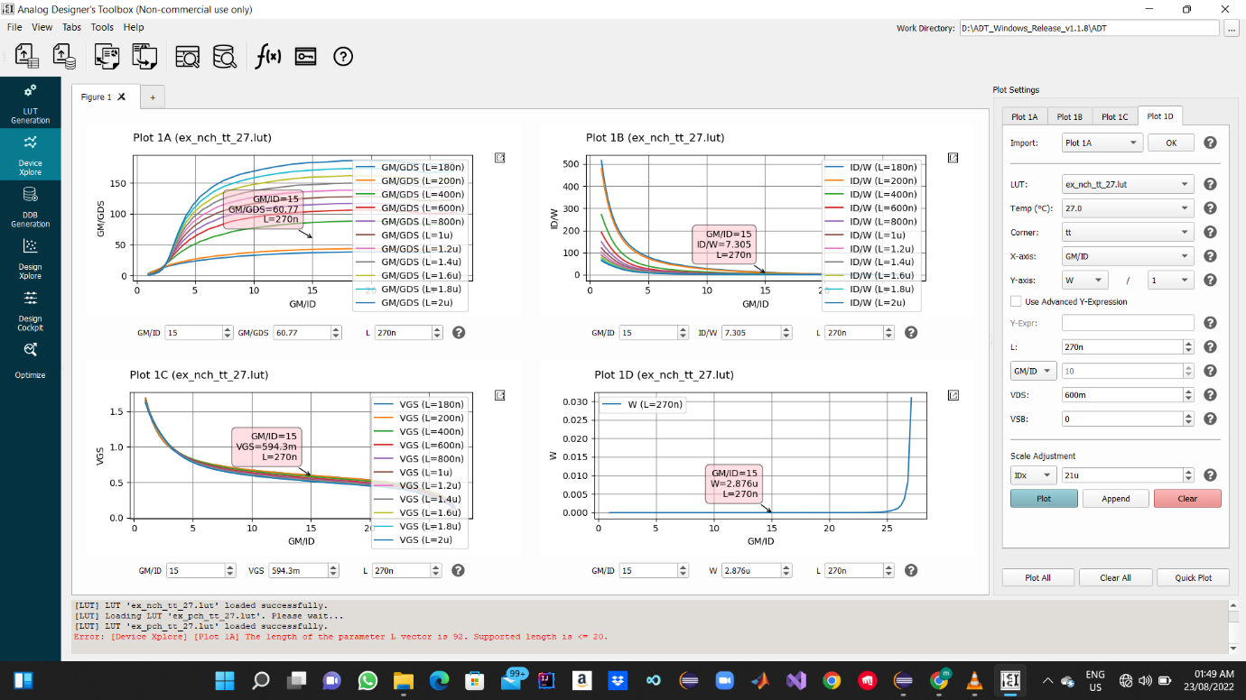

Used Some Hand analysis to get Gm and with the Assumptions got the above points , Vgs Determined to Add CM to bias The devices.

Tail Current Source Sizing

|  |  |
| --- | --- |
| Gm/id assumptions | For the input stage we used large gm/id as its gm Contributes at The gain and less random mismatch , while for the load and tail cs we used small gm/id as there gm doesn’t Contribute at Gain and to have smaller area to get small capacitances from them and to have a less effect of VDS on Current As Va increase. |
| Ro assumptions | We used 5ro for The load To have A Less VDS Effect at the current from The load |
| Tail Current Source L assumptions | As L increase Ro tail cs increase so Cm gain decrease and cm rejection ratio increase , and have an accurate current Value as VDS Effect Decrease as Ro increase . |

Question 6: Test Script

Matlab Results (No Parasitic Caps)

Question 7:

Netlist & Simulation Results (No Parasitic Caps)

|  |  |  |
| --- | --- | --- |
|  | Specs | Spice Results |
| GBW | 100 Mega hz | 1.77*Mega*51.2 = 92 Mega hz |
| DC Gain | 34 db | 34.3db |

The Dc Gain Is Achieved but there is an error at the GBW this is due neglecting the parasitic caps , but it will effect the GBW as there order of magnitude is the same as Cl (Femto).

PART 2 :

Question 1

Input Pair Sizing While Taking Parasitic Caps in calculations

Current load Sizing While Taking Parasitic Caps in calculations

Tail Current Source Sizing While Taking Parasitic Caps in calculations

The Methodology I Used Was Calculating Both CDD for Input and Current Mirror Load Then Calculating Gm From GBW Equation And Continue Design As usual .

Question 2:

Matlab Function

The Function Takes The Effect of Parasitic Caps in Consideration it Iterates Until it Founds The best Sizing values With 8% Percent tolerance to stop at the gm Value.

|  |  |  |
| --- | --- | --- |
| ADT  With Parasitic Caps | MATLAB Part1  No Parasitic Caps | MATLAB Part2  With Parasitic Caps |
| Input Pair:  W= 3.2u  L=280n  Current Mirror Load :  W= 37.24u  L=1.9u  Tail Current Source :  W=9.598u  L=1u |  |  |

There Are Difference Between ADT And Matlab Results As Matlatb LUTs Are made on Hspice While ADT LUTs are made on LTspice , MATLAB Function 2 Has Tolerance 8% Stoping Iterations Condition , When The gm is changed while Calculating it from The GBW as Adding caps in calculations .

Question 3:

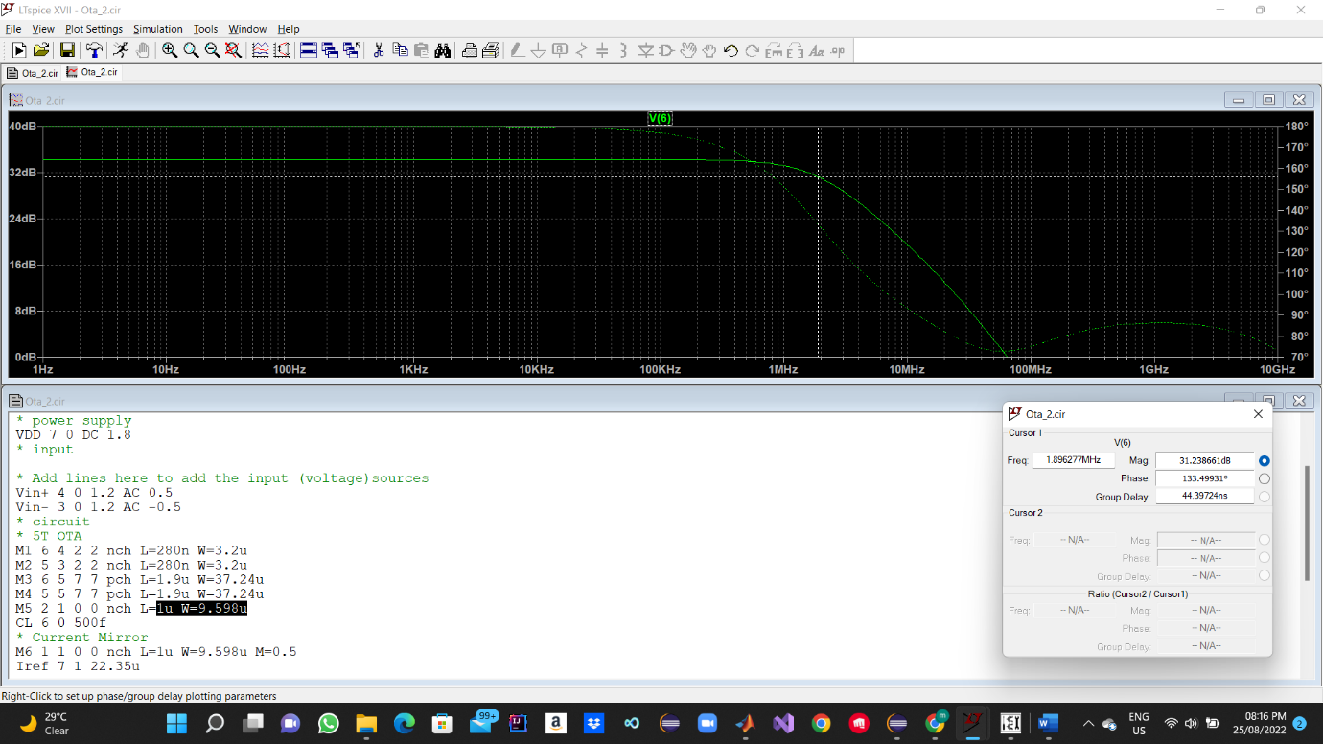

|  |  |  |
| --- | --- | --- |
|  | Specs | Spice Results |
| GBW | 100 Mega hz | 1.89*Mega*51.286 = 97 Mega hz |
| DC Gain | 34 db | 34.2db |

As we took the Parasitic Caps Into Consideration We Have A better Accuracy for the specs as the error become 3% only .